**About us:**

Web Solution International Network (WSIN) Global is freelance consultant team, which has been operating their services worldwide since the year early January, 2020. As a team lead this freelancer group. This is Md Jahedul Anwer, actively available to meet up customer demand very actively and effectively, as I have completed Masters of Business Administration (MBA) degree with IT & e-business from Lansbridge University Canada and also completed Masters of Science (MSc) degree from University of Dhaka, with Zoology - Specialization on Fisheries. I have vast knowledge & technical experiences as I engaged himself last 34 yours duration to work both profitable and non-profitable sector. I work 24 years duration for implement non-profitable sector, humanitarian work projects and programs with different non-government national and international organizations are working in Bangladesh. Also work to implement agricultural interventions as an entrepreneur 7 years durations very successfully. I have very successful technical knowledge in Agriculture, Aquaculture, Poultry & livestock, Environment and bio diversity conservation. I have also has outstanding knowledge on different types of handicraft projects including Block, Batik, Fashion designing, Bamboo & Wooden crafts and others. I am ready to launch new fashion designing and supply as per work order any dress demands in the markets as per customer demands from any countries from anywhere from all over the world.

Md Jahedul Anwer

Team Lead

WSIN Global Freelance Consultancy Tem

**Contact us:**

Md Jahedul Anwer

Team Lead of WSIN Global Freelance Consultant Team.

Phone:+8801787498114 (whatsapp+Telegram).

Skype: Md Jahedul Anwer

Facebook: Md Jahedul Anwer.

E mail: [wsinglobal@gmail.com](mailto:wsinglobal@gmail.com)

LinkedIn: <https://www.linkedin.com/in/wsinglobal/>

Facebook: <https://www.facebook.com/wsinglobal>

Instagram: <https://www.instagram.com/wsinglobal/>

Web site: [www.wsinglobal.com](http://www.wsinglobal.com)

Web based e mail:

[TL-DMA@wsinglobal.com](mailto:TL-DMA@wsinglobal.com)

Customer service:

[service@wsinglobal.com](mailto:service@wsinglobal.com)

[finance@wsinglobal.com](mailto:finance@wsinglobal.com)

[procurement@wsinglobal.com](mailto:procurement@wsinglobal.com)

[advertising@wsinglobal.com](mailto:advertising@wsinglobal.com)

**WSIN Global providing services globally, this freelance consultancy team, are available to start works on:**

We are ready to serve work for non-profitable humanitarian non-government organizations, government departments, Educational Institution and Individual population’s all over the world globally.

Our speciality areas are following:

Writing article, Report, Content, Case study/Success Story, Script, Organization or individual profile, Glimpse, Brochure, Resume, Autobiography, Project Proposal both business and humanitarian – Technical, Financial with program planning an logical framework, Assignment, Research proposal for higher studies Masters, PhD, Contract agreement and any other.

Set up Planning Monitoring Evaluation Accountability and Learning’s (PMEAL) Department within the non-profitable, humanitarian organization/projects. Design Information Education and Communication Materials.

Digital Marketing, Web Data Research, Web Scraping, Lead generation, Social media marketing, Search Engine optimization, advertising for business organisations or any. Data entry, Online Survey, Typing, Re-Typing Web data research, File Conversion, Translation, HR solution and Head Hunting for companies and job search for national and international jobs for individuals.,

Designing Logo, Banner, Report Cover page, Poster, Advertisement announcement / promotion speech, Facebook, LinkedIn Cover page or any other tasks.

We can connect you for your product sell or buy any; we search best solution for you to the right person, department and organization and others services as per request.

All solutions under in an one umbrella all over the globe, our services are providing both remote, on place & hybrid. .

We have wide range of network with different national & international forum, Institutions, Organizations, Government and non-government departments and individuals from almost more than 100 different countries from all over the world and we are connecting actively through using different social media connections. We are collecting work through LinkedIn, Facebook, Instgram, You Tube, up work, fiver, freelancer and some other networks. We also have some direct connection with buyers and we are providing some time directly on place work in country Bangladesh. We are very soon going to cover USA, Canada, Netherlands, New Zealand, French, Dubai, Norway, United Arab Emirates and some other countries as necessary. We have our freelancers working with us in our team are living there and we are actively connected-Friends and relatives.

We are very friendly behaviour and multi-level technical knowledge to deliver the works remote and on place within meet up the deadline. We are professional to adapt multi-cultural working environment as we are able to go any country on place and serve for you.

We are cordially invited to enquire us, write us e mail or talk, chat to know our services to meet up your demand soon.

We are eagerly waiting to see your response soon.

Warm regards.

MD JAHEDUL ANWER

Team Lead & Freelance Consultant

Phone: +8801787498114 Whatsapp, Telegram.

e-mail: [wsinglobl@gmail.com](mailto:wsinglobl@gmail.com)

Web: [www.wsinglobal.com](http://www.wsinglobal.com)

**Vision Mission & Objective of WSIN Global Freelancer Working Team:**

**Vision:**

We are structure and secure the relationships between companies, non-government and Government organizations, National and International Forum, Individual person, Education Institutions, buyers and talented self-employed individual workers.

**Mission:**

We are creating self-income generation through hourly and short contracts from different companies and organizations for freelancer survivalist.

We will satisfy the client organizations as per meet up their deadline with maintaining their appropriate quality and quantity.

We are dedicated for providing multi skill works from all over the world both remotely and on place as we have connected freelancers in different countries all over the world.

**Objectives:**

WSIN Global creating employment opportunities through remote work which will be based on different social media online.

Build inter personal relationships with clients, buyers and freelancers to perform better within the time deadline.

Utilization of the people skill for providing right quality works for companies and individuals worldwide.

Warm regards and welcome to connect with us.

MD JAHEDUL ANWER

Team Lead & Freelance Consultant.

Phone: +8801787498114 Whatsapp, Telegram.

e-mail: [wsinglobl@gmail.com](mailto:wsinglobl@gmail.com)

Web: [www.wsinglobal.com](http://www.wsinglobal.com)

**Speech from Team Lead of WSIN Global:**

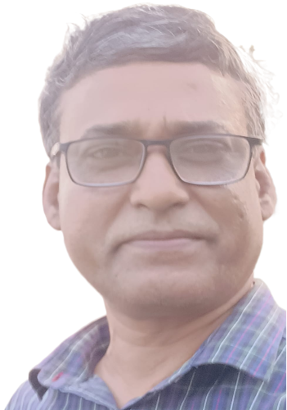

**I am very glad and amusingly invited all of you from different countries from all over the world to connect us at any time to get our services remotely and on place.**

**We have wide range of connection between companies and freelancers worldwide, we are doing freelance work for digital marketing through remote and some time we also contract on place with meet up deadlines from our clients.**

**Our freelance team WSIN Global is highly dedicated any solutions through social media, web because we have strong Information Technology background and experience on IT field.**

**Those who are in Asia you can meet our decorated office in Dhaka, Capital city and remote also all are welcome to meet us through zoom conferencing to know our potentiality to serve you better performance for you. Hope our dedication to serve you better which exactly what you want. Don’t worry you can meet us at any time through conferencing: visit our web:** [**www.wsinglobal.com**](http://www.wsinglobal.com)

**Hope you will enjoy our services from us.**

**To know all of our services and our potentiality, technical knowledge and experiences connect us at any time.**

**Warm regards**

**Md Jahedul Anwer**

**Team Lead and Freelance Consultant of WSIN Global FREELANCER Team.**

**Call us+8801787498114 Phone+whatsapp+telegram.**

**e mail: wsinglobal@gmail.com**

**Web: www.wsinglobal.com**

**Communication between WSIN Global Freelancer Team and Stakeholders:**

**Warm regards**

**Md Jahedul Anwer**

**Team Lead and Freelance Consultant of WSIN Global FREELANCER Team.**

**Call us+8801787498114 Phone+whatsapp+telegram.**

**e mail: wsinglobal@gmail.com**

**Web: www.wsinglobal.com**

**Operation / Implementation strategy:**

WSIN Global has been providing digital marketing services freelance work through using social media organizations.

We have team Lead & Consultant with some freelancer individuals who are very dynamic to provide services for different technical skills for all over the world any countries.

We are freelancer team; our priority is to provide best quality services on time accurately and exactly.

We are potential for solution multi task assignments.

Our services for Business Organizations, Entrepreneurs, Research Organizations, Educational Institutions, Humanitarian-Charitable Non-Profitable Organizations and Individuals even those who want one page typing or one million data entry, data analysis in the software system and or any other services.

We also arrange to connect with buyers and sellers s we have connected all over the world populations.

**Our priority is customer satisfaction first with quality of work on time delivery.**

**Warm regards**

**Md Jahedul Anwer**

**Team Lead and Freelance Consultant of WSIN Global FREELANCER Team.**

**Call us+8801787498114 Phone+whatsapp+telegram.**

**e mail: wsinglobal@gmail.com**

**Web: www.wsinglobal.com**

**Some work sample:**

Logo:

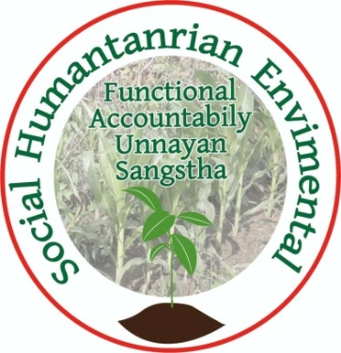 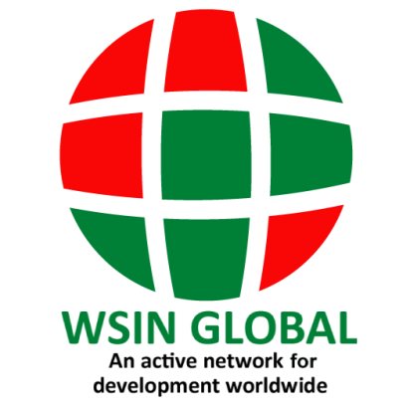

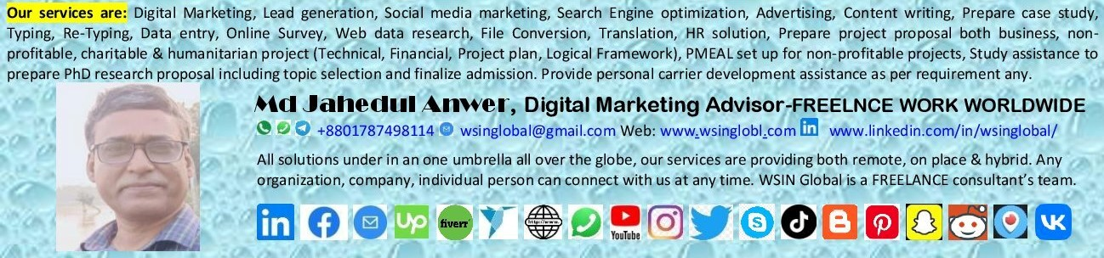

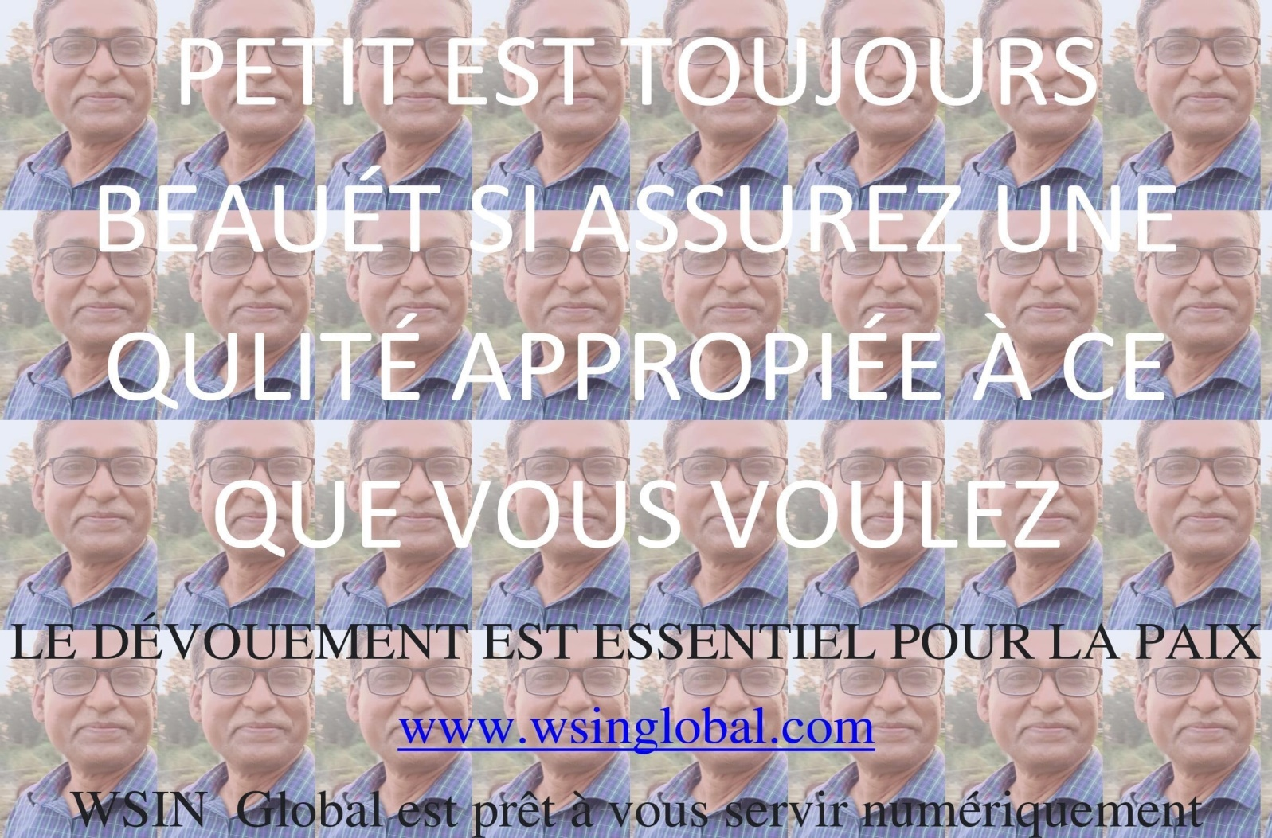

Mote Detail Please Connect our you Tube Channel: **WSIN GLOBAL@wsinglobal5339**

**Publications for Sale:**

**Set up PMEAL Manual:**

Planning, Monitoring, Evaluation, Evaluation, Accountability & Learning’s for Non-Profitable, Charitable, Humanitarian projects

**Reporting & Documentation Manual**

**Protection of Sexual exploitation and abuse (PSEA)**

**Research Study Guide & Proposal Preparation**

**Program Designing, Development & Execution**

**Preparing Case study or Success Stories**

**Pickle Production Manual**

**Semi Intensive Carp-Polyculture Manual**

**Kitchen gardening to meet up family nutrition**

**Picture for SALE:** Selling natural creative pictures.

Sample picture: more picture will attached herewith soon:



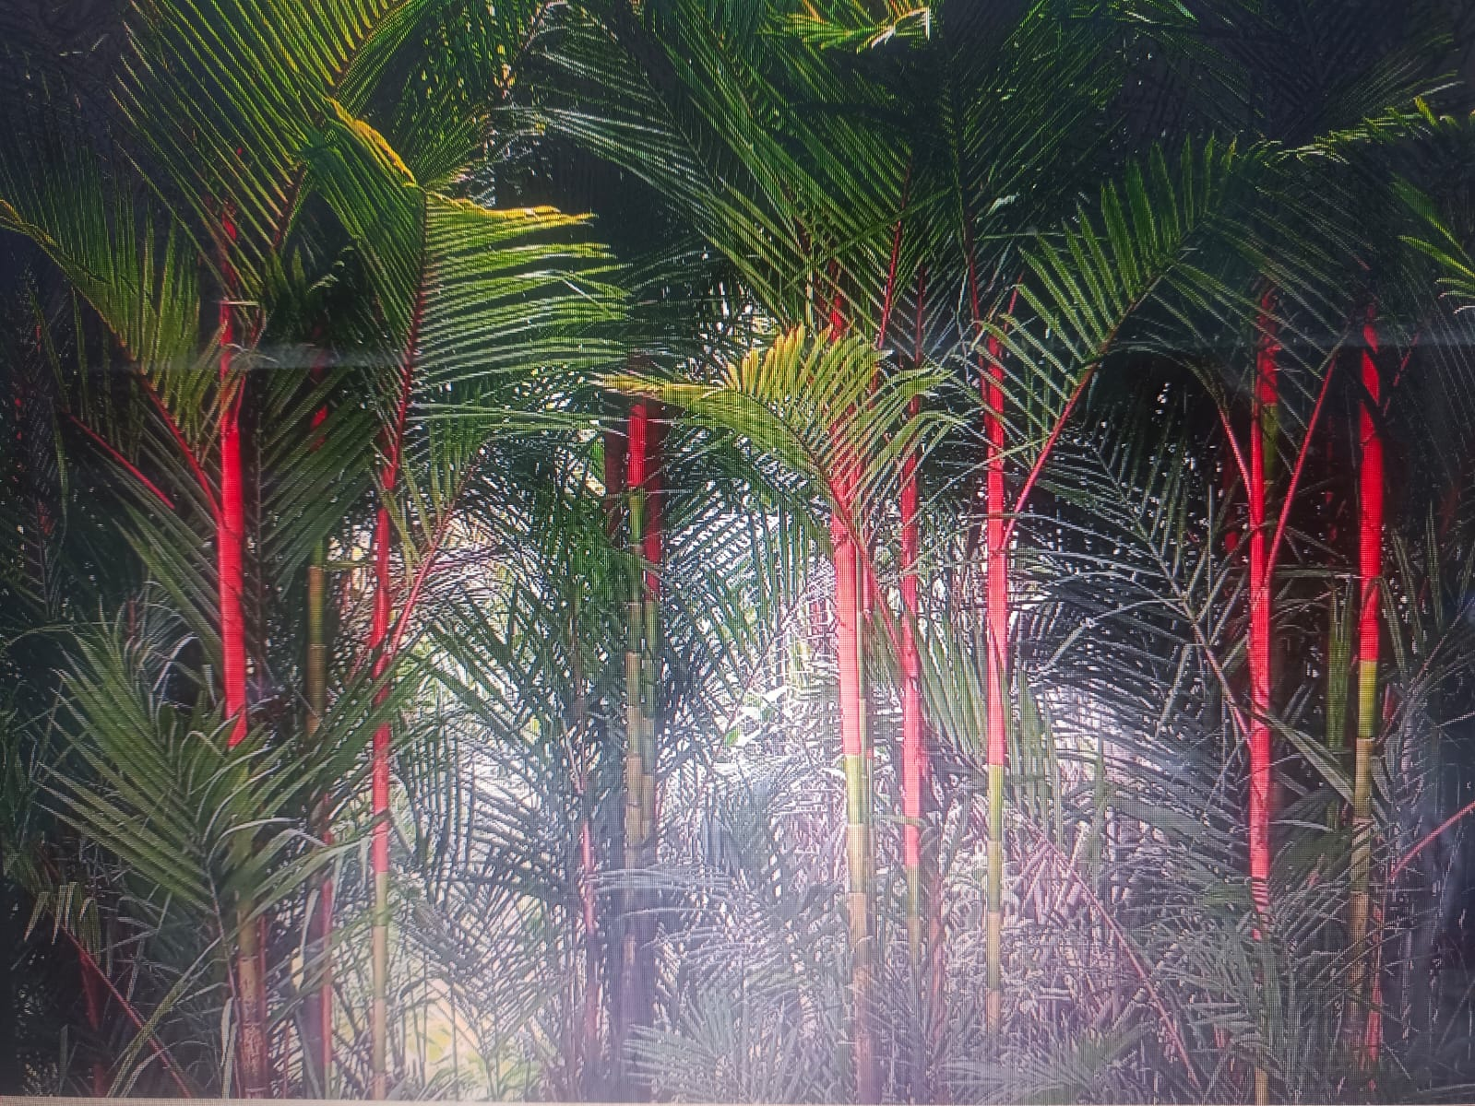

Nipa Palm picture from Nature.

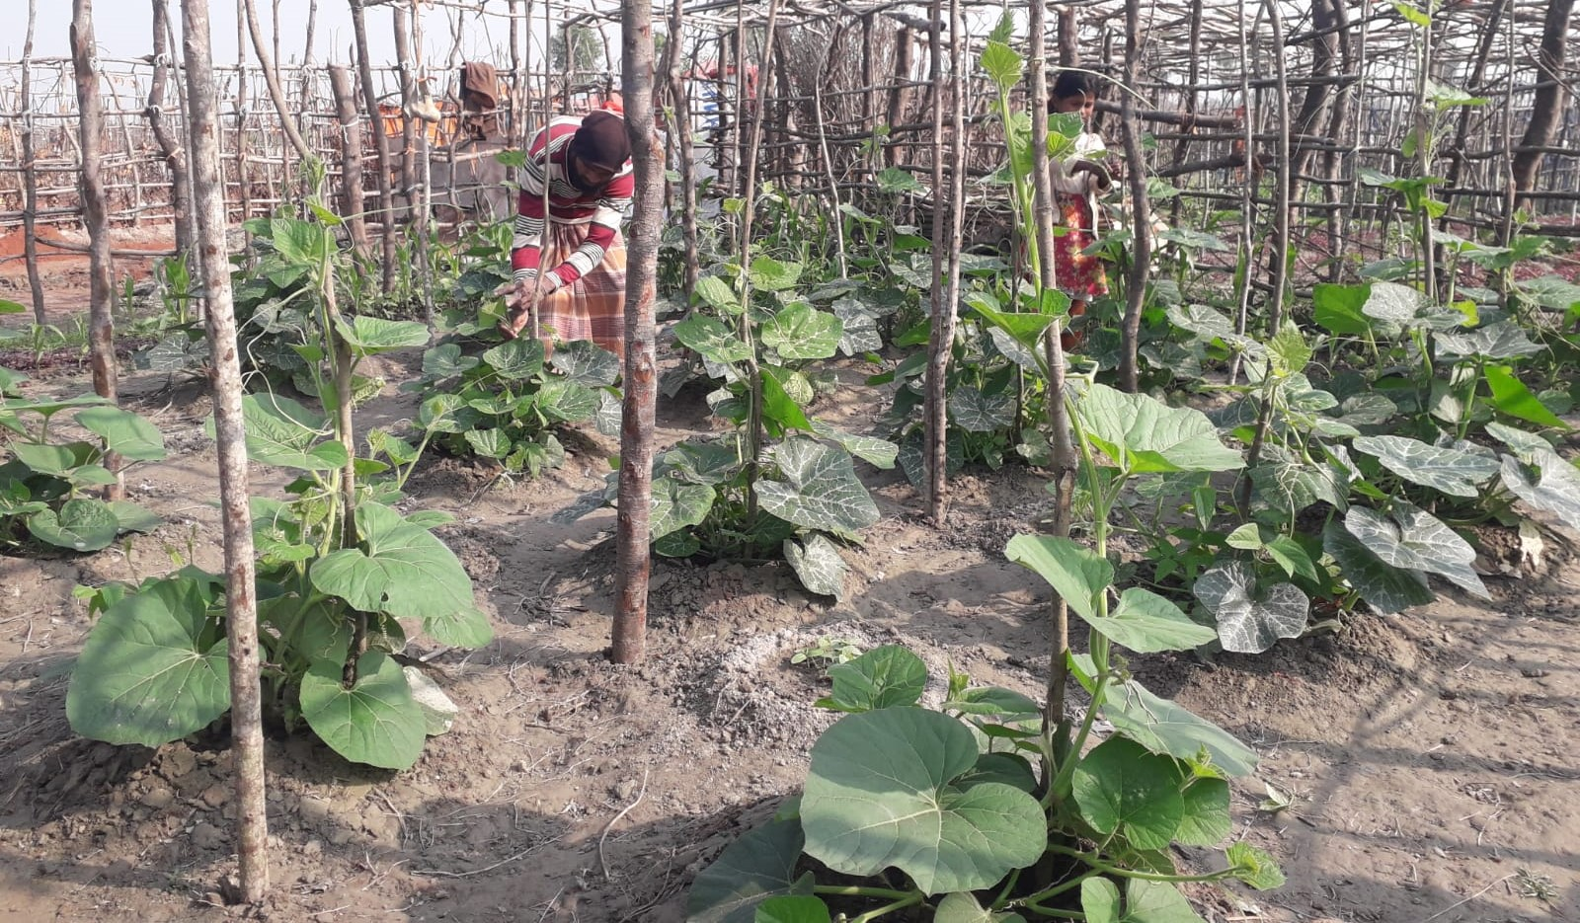

Vegetable gardening.

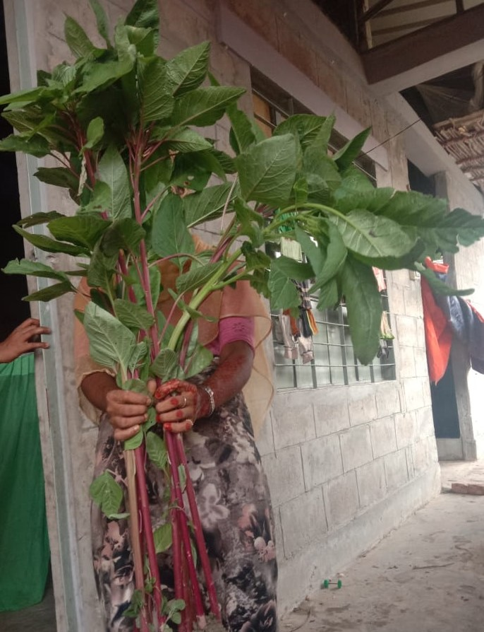

Vegetable production.

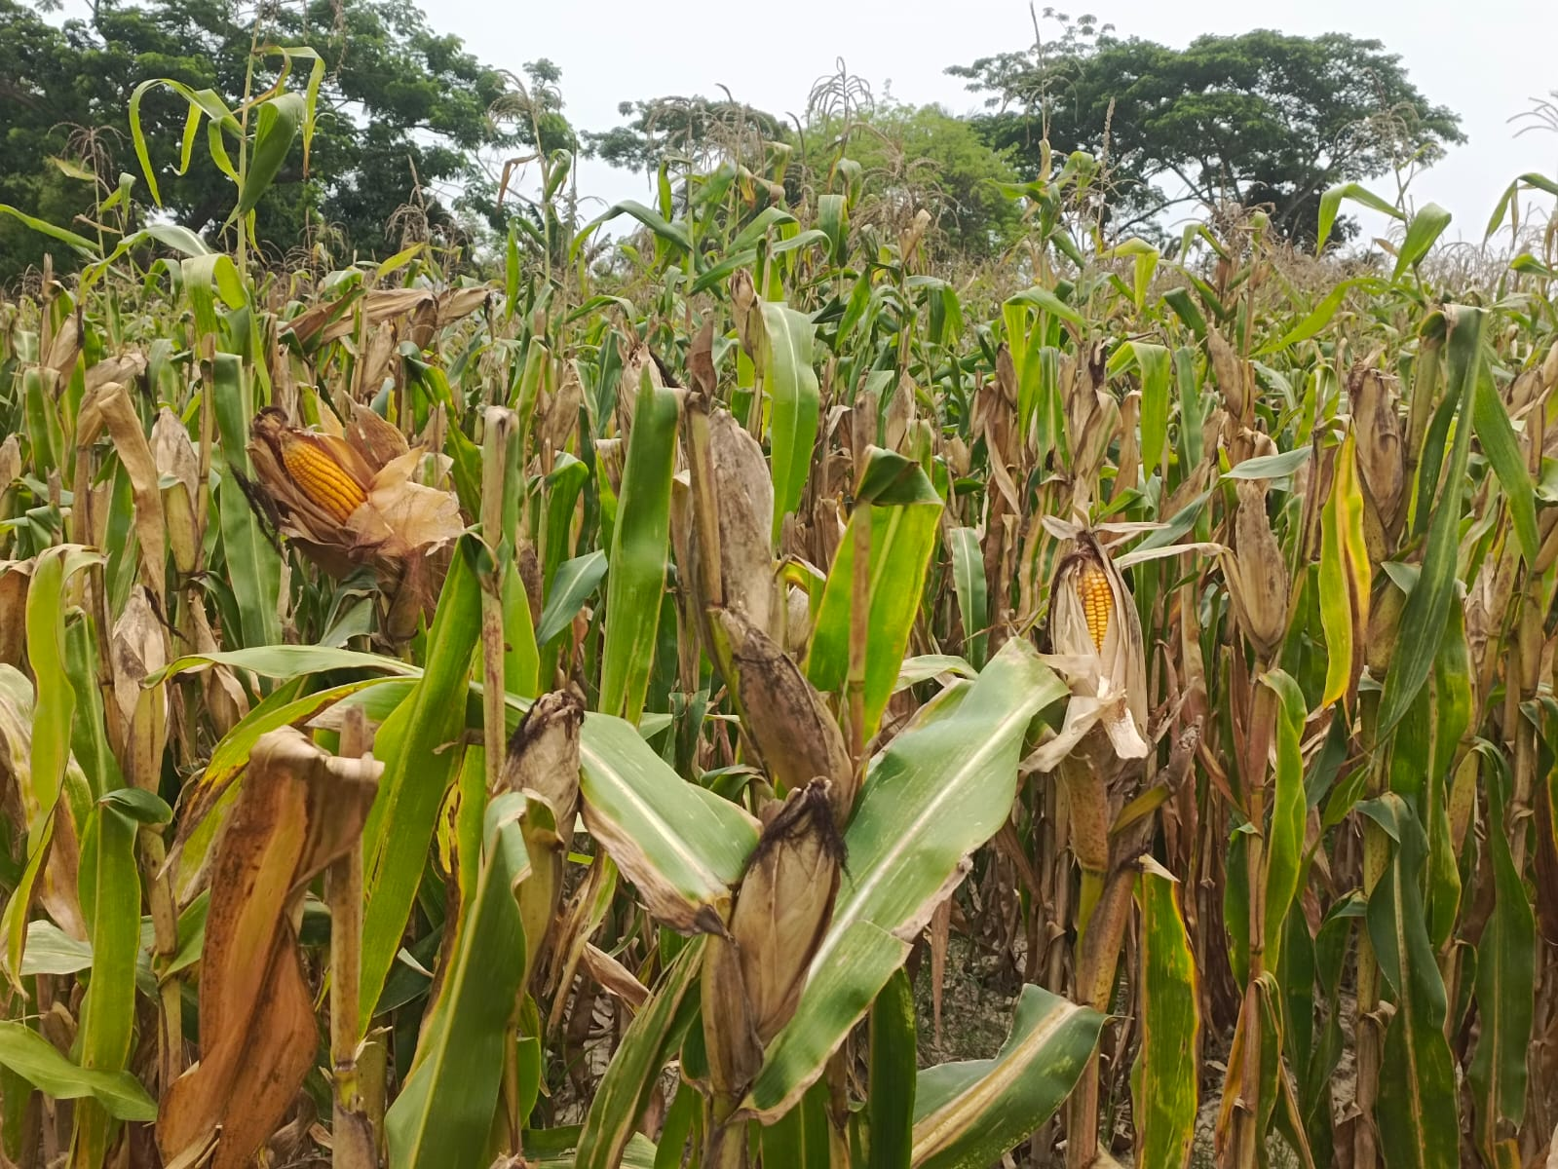

Maize plant

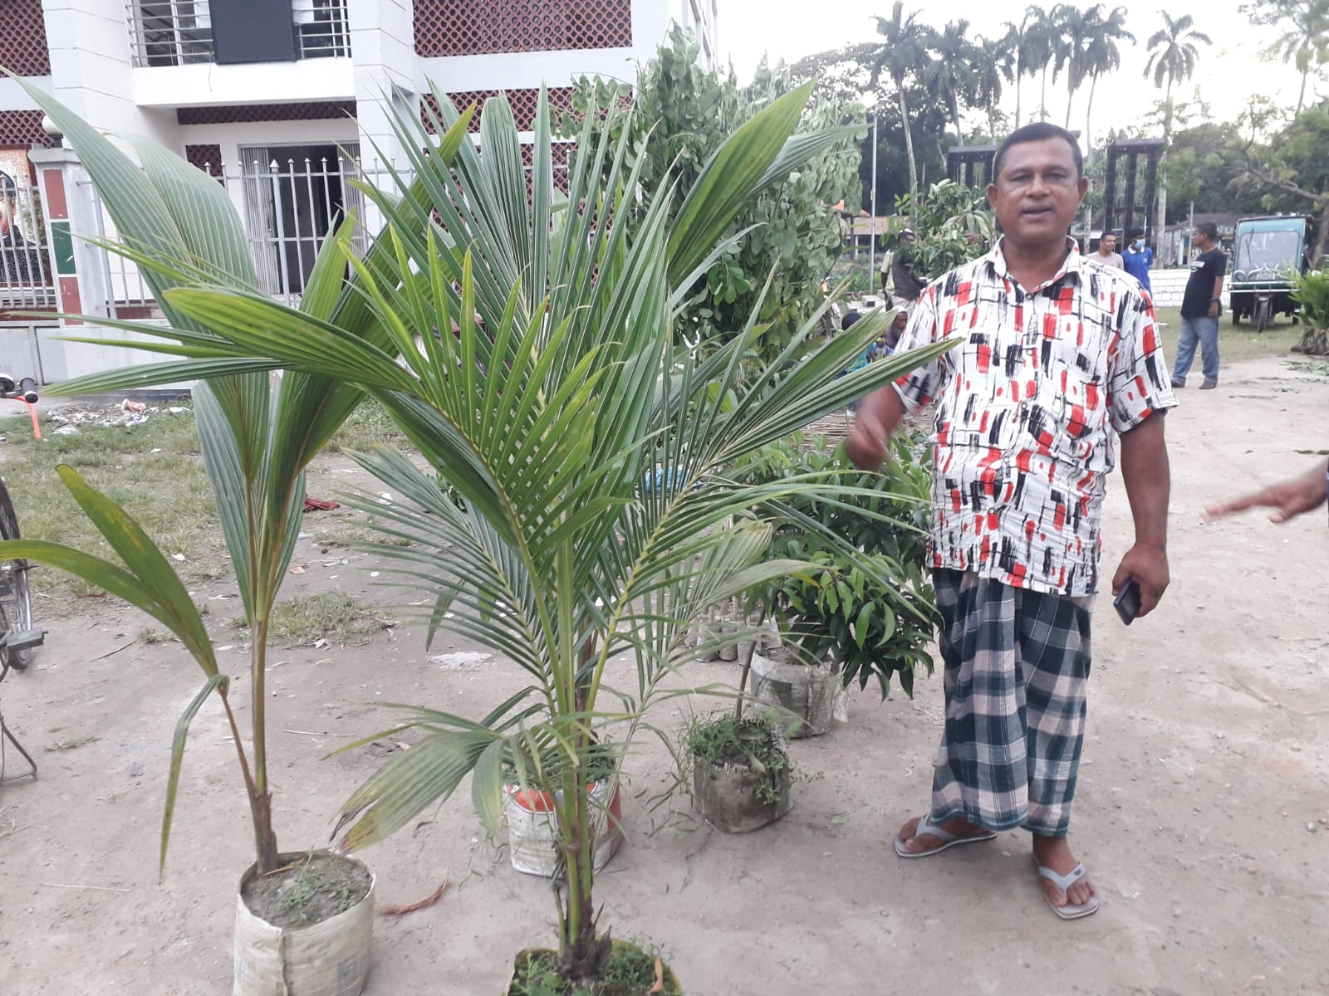

Selling nursery plant.

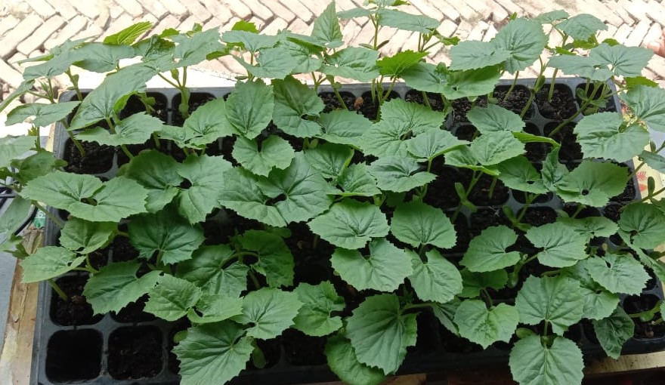

Bitter guard sapling.

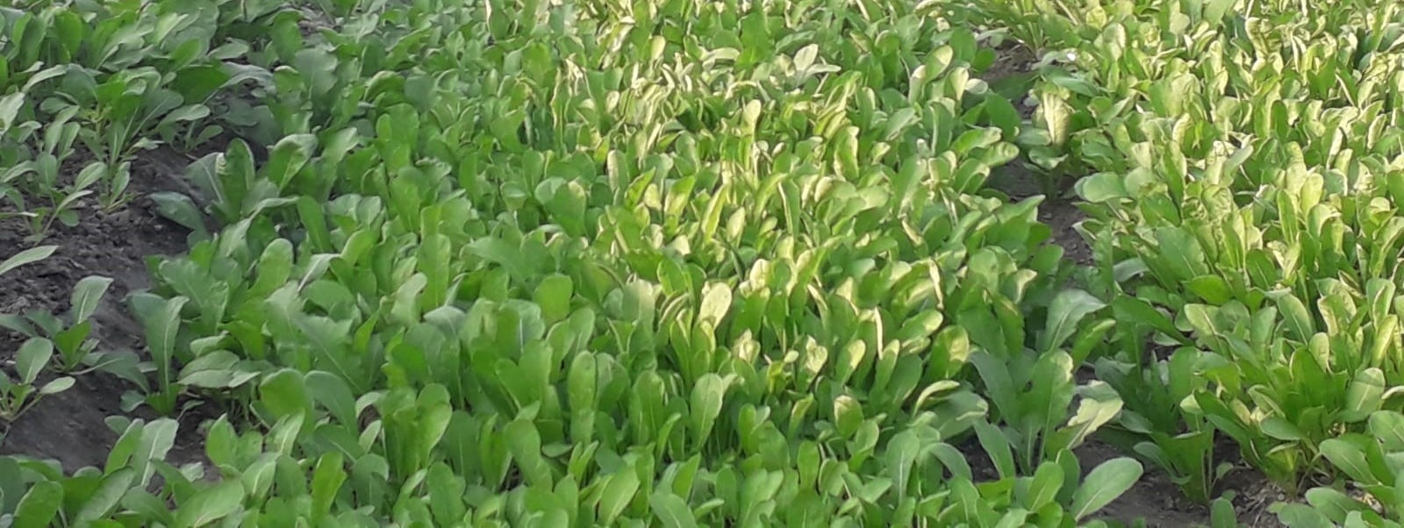

Leaf Vegetable plant

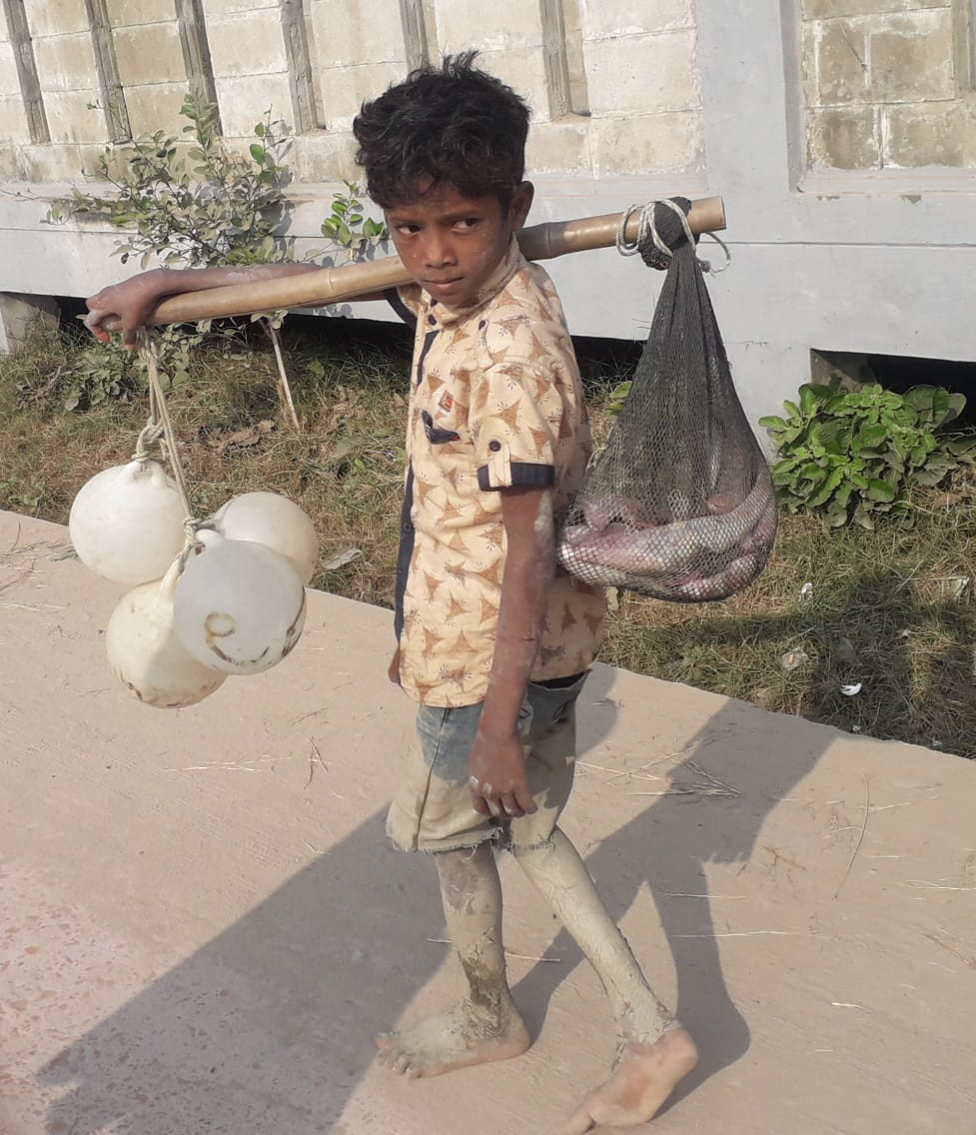

Child labour returning from the river after catch fish from heavy risk costal location in the nearest bay of Bengal in Bangladesh (Hazardous work for youth & Children’s).

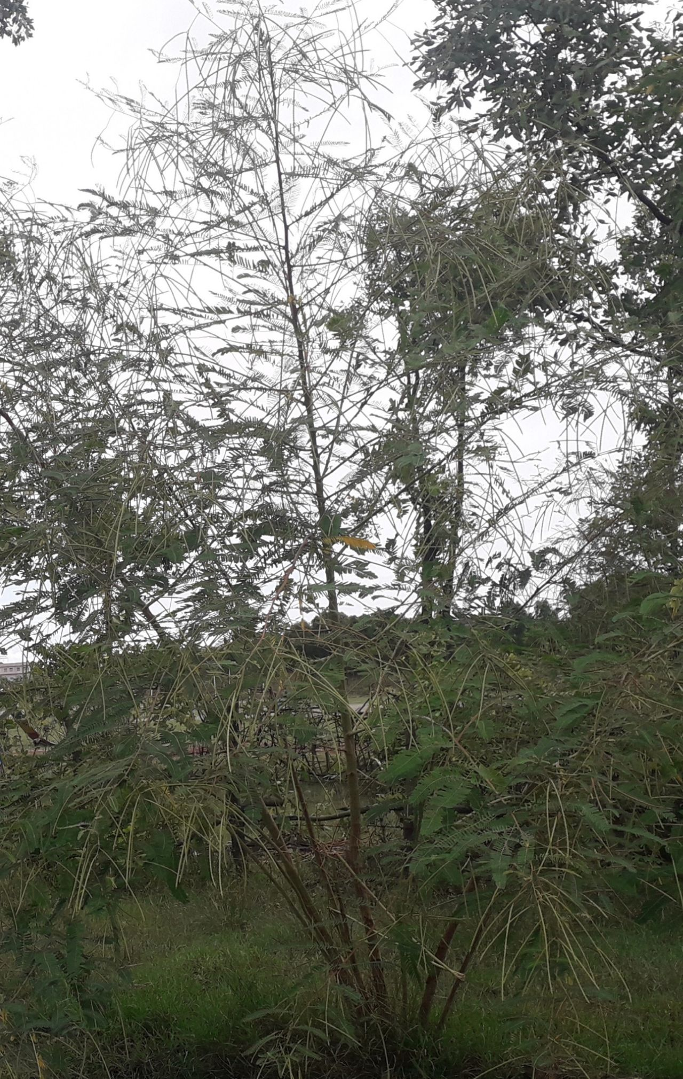

Picture: **Sesbania Aculata** is best for agro based plants and environmentally best species..

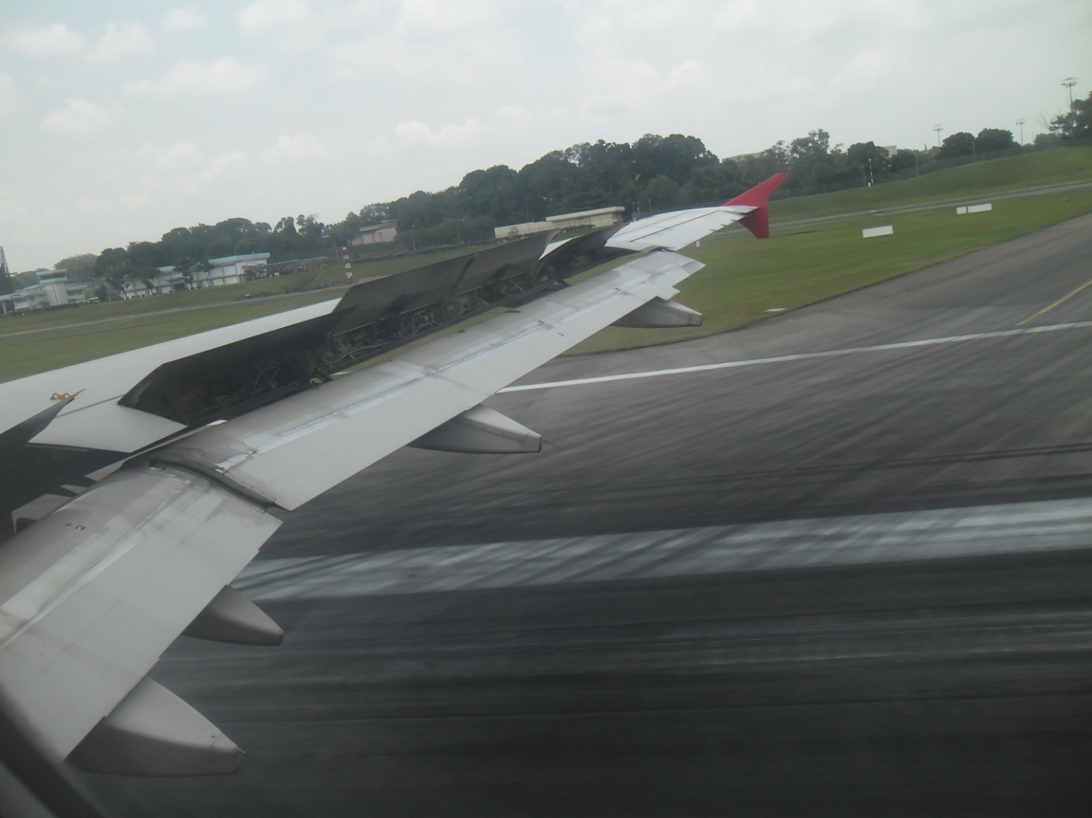

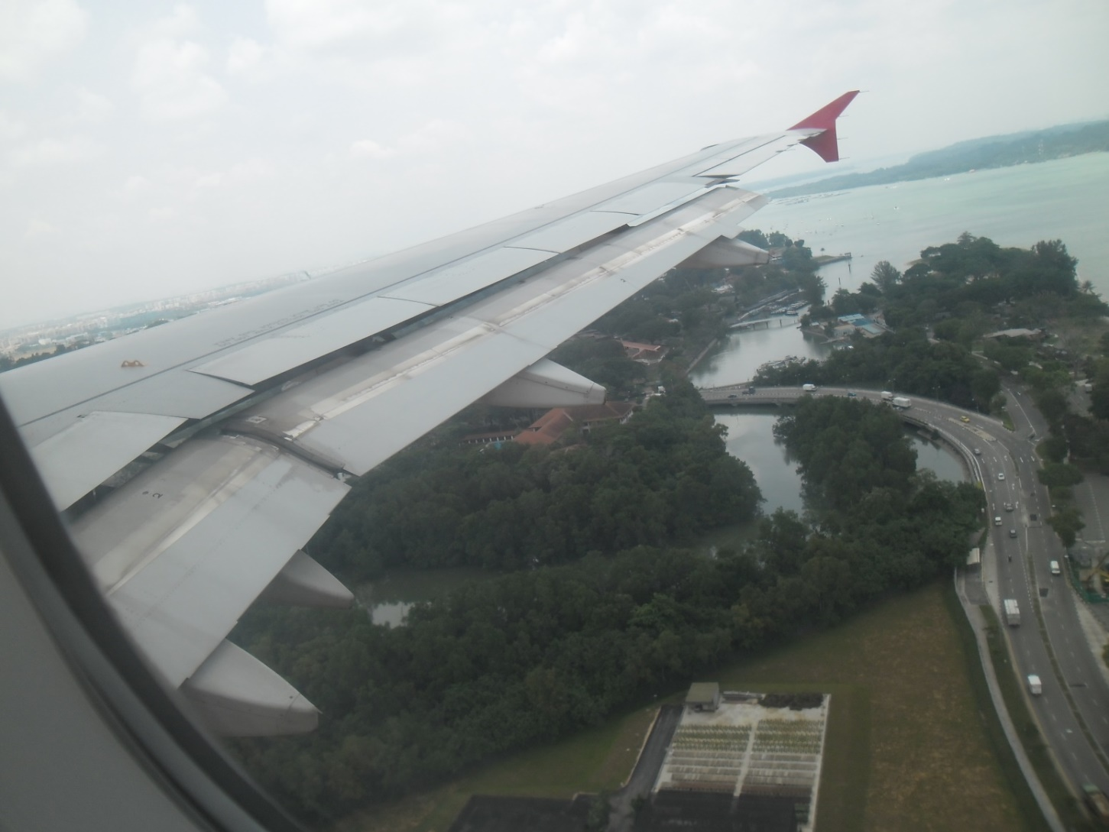



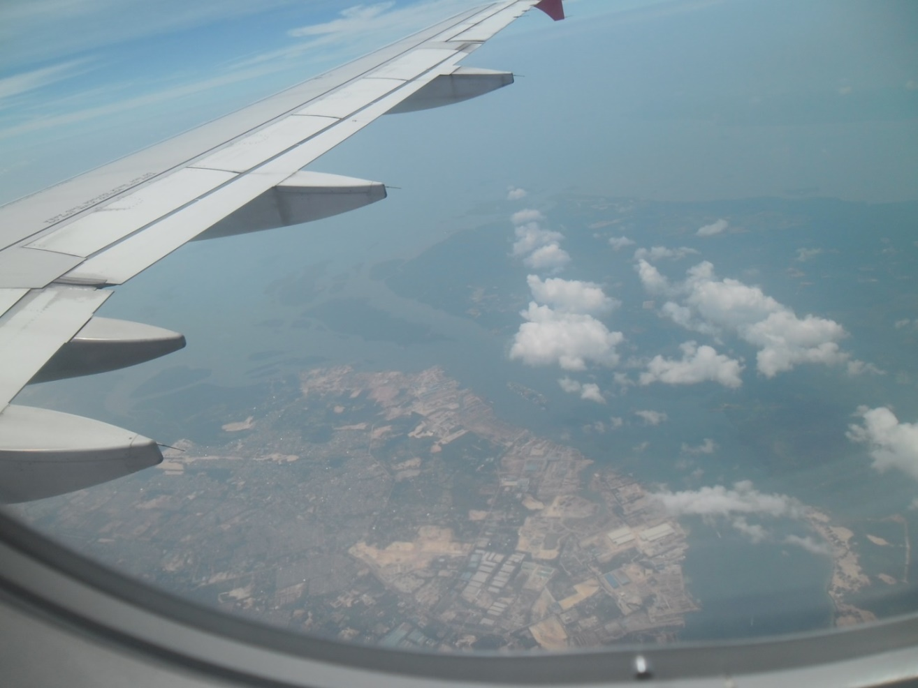

Interested please come to meet our office or Online Zoom conferencing:

Md Jahedul Anwer

[Www.wsinglobal.com](http://Www.wsinglobal.com)

[wsinglobal@gmail.com](mailto:wsinglobal@gmail.com)

Phone+8801787498114 (Telegram, Whatspp).

[TL&DMA@wsinglobal.com](mailto:TL&DMA@wsinglobal.com) [service@wsinglobal.com](mailto:service@wsinglobal.com)

**Study Assistance, Support for Higher Studies Worldwide:**

WSIN Global freelance team will provide study supports for interested students to settle admission to study Masters and PhD with well remount universities worldwide. We can prepare research proposals for admission processing. We will counsel students to choose well ranking universities for all over the world countries.

The student’s and guardians can consult us to find out the best well ranked universities, college, schools for their children’s and relatives.

**Entrepreneurship Consultancy Support for:**

WSIN Global freelance consultant tem is ready to provide to prepare business proposal including Financial, Technical and Detail operation and Execution plan for 3-5 years. We also will provide trainings s necessary.

Business program/project development, consultancy supports we are providing for the following:

* Aquaculture project.
* Cages aquaculture.
* Catfish Culture.
* Crab Culture.
* Communication for Crab meets **Cain Crab production & supply exports through export companies.**
* Market linkage for any production buy or sell import or export to any country or for any countries, any items, we will ensure though registered exports and Importers.
* Export Import seeds through export, Import agencies, any required.
* Landscape Gardening (Including Roof Top, Balcony and Landed).
* Riverside Biological Embankment.
* Apiculture farming.
* Mushroom gardening.
* Vegetable Gardening.
* Fruit Gardening.
* Rabbit Farming.
* Chicken farming.
* Goat Rearing.
* Pigeon Rearing.
* Handicraft entrepreneurships on Blok, Batik, Bamboo Craft, Wooden Craft, Cain Craft and others necessary.
* Any other supports as per requirements.

Don’t hesitate to connect us through [www.wsinglobal.com](http://www.wsinglobal.com)

Call: +8801787498114 what Sapp, Telegram,

Skype: Md Jahedul Anwer or Zoom conferencing.

E mail: [wsinglobl@gmail.com](mailto:wsinglobl@gmail.com) Or [TL&DMA@wsinglobal.com](mailto:TL&DMA@wsinglobal.com)

Or [service@wsinglobal.com](mailto:service@wsinglobal.com)

**HR Solution:**

Head hunting for deploy the right person for non-profitable or Business organizations, companies for all over the world.

We have a roaster, Resume Bank so that time to time we can provide some skill manpower for in country and overseas.

We also arrange individual carrier counselling to find a right job nationally and internationally. Like as: We can arrange job through individual job profile with BD Jobs in Bangladesh, Nakuri, Mudah, relief web, UNV and specific company / organization wise search and applied for expected position.

We also guide and brief for job description, interview preparation for written and Viva test.

We can also assist to find out individuals, for those who are seeking job/work oversees for any countries, any skill / semi skill/ unskilled fresh both educated on non-educated.

We can assist to prepare Resume for individuals, Cover letter for specific position when need to apply and online base any roaster data fill up for carrier development.

Don’t hesitate to connect us through [www.wsinglobal.com](http://www.wsinglobal.com)

Call: +8801787498114 what Sapp, Telegram,

Skype: Md Jahedul Anwer or Zoom conferencing.

E mail: [wsinglobl@gmail.com](mailto:wsinglobl@gmail.com) Or [TL&DMA@wsinglobal.com](mailto:TL&DMA@wsinglobal.com)

Or [service@wsinglobal.com](mailto:service@wsinglobal.com)

**Market Linkage Development:**

WSIN Global freelance consultants are always ready to provide services for Market Linkage Development all over the world, to grow the businesses we can provide the following supports s per requirement:

* Industrial raw materials source find out for availability to buy and sell. We are just providing information to connect between and buyer and seller as middleman.
* We also can suggest availability of manpower, we will not process and all processing will be done by the government and respective departments / organization/institutions.
* Information we can provide you whatever you want to know the source of items you want to buy specific items, yes we can provide you detail specific information for sale or buy from any parts from the world to another part.
* We can arrange digital campaign for you.
* We can announce digitally for you.
* As much as many sources we can notify you as per your requirement.
* Any other business enquiry.

**Charity, Humanitarian supports to reduce worst vulnerability:**

WSIN Global total earnings from freelance consultancy services, we will spend at least 15 - 25 per cent of amount for worst vulnerable populations to reduce their vulnerability, which will be following interventions, if the amount will big, then assign for Non-Government organizations, they will implement and report us regularly:

* Cloth, Food will be provided for Widow, Orphan child, Street children, Working Children, Disable, Old age women and men those who aren’t able to earn any. Target: 100 for 2 festivals: us$1500.00

The intervention currently already started.

* Stipend distribution for some children’s on regular basis, considered extremely poor adolescent Girls and Boys. Disable Childs, Orphan children.

The intervention currently already started. Our target: 100 students, yearly: us$6000.00

* Total 300 adolescents and small children’s will enjoy reasonable meals will fasting months in during every year Ramadan; we selected orphan children’s in Madrasah (RAMAN IFTHAR), Cost for 30day meal: us$550.00. (Yearly).

* Al Quran, Arabic books numbers of copies supplies, for study those who are very poor madrasah students. As required. (Tentative: us$250.00).
* Redeem madrasah student fees, totally free; Established madrasah and continuing for 100 students’ last 14 years duration and currently on going. The operation cost providing my elder brothers from Australia. Planning for three story building, seeking budget: 3 story building construction, Ground Floor Masjid for regular prayer for nearest villager community.

First Floor, for study Madrasah Students, boys and Girls.

. Second Floor, Orphan Children’s residential & studies (50-100 capacity).

Construction of three story building: Approximately: us$33,555.00.

From Australia: Grant maintaining, last 14 years: us$ 1190.00 (Some time more or

less, depend on actual cost).

* Every year from freelance earnings arranging improve meal 1 to 2 time’s yearly, biryani, Polaw (Fried Rice) with soft drinks for 300 village children’s, adolescents and small children’s (Its including Madrasah, Orphan & Some community Children’s). Estimated cost: us$945.00 (Yearly 2 time)
* Some vegetable seed distribution for poor villagers, widow, orphan and disable: Estimated cost: us$ 1905.00 (200 person, 2 time in a year, Sweet Corn, Mize, and some vegetable , fruit saplings).
* Winter Blanket distribution for almost 50 worst vulnerable populations once yearly. Estimated cost: us$ 775.00.
* Adolescents & Small children’s playing instruments: for 150 children’s: Approximate cost: us$365.00.
* If nay incident happen, special assistance for affected populations in the community. Estimated: us$950.00.

Anyone can join for provided the list of interventions, any, if want:

Our partner organization, **SHEFA Unnyan Sangstha**, Dhaka, Bangladesh is directly implementing all of the mentioned charitable interventions. Some more partner organisations are coming soon in our connections.

E mail: [wsinglobal@gmail.com](mailto:wsinglobal@gmail.com) Phone, Whatsapp and Telegram: +8801787498114.

Visit web: [www.wsinglobal.com](http://www.wsinglobal.com)